Safe Ministry with Persons of Concern Policy | 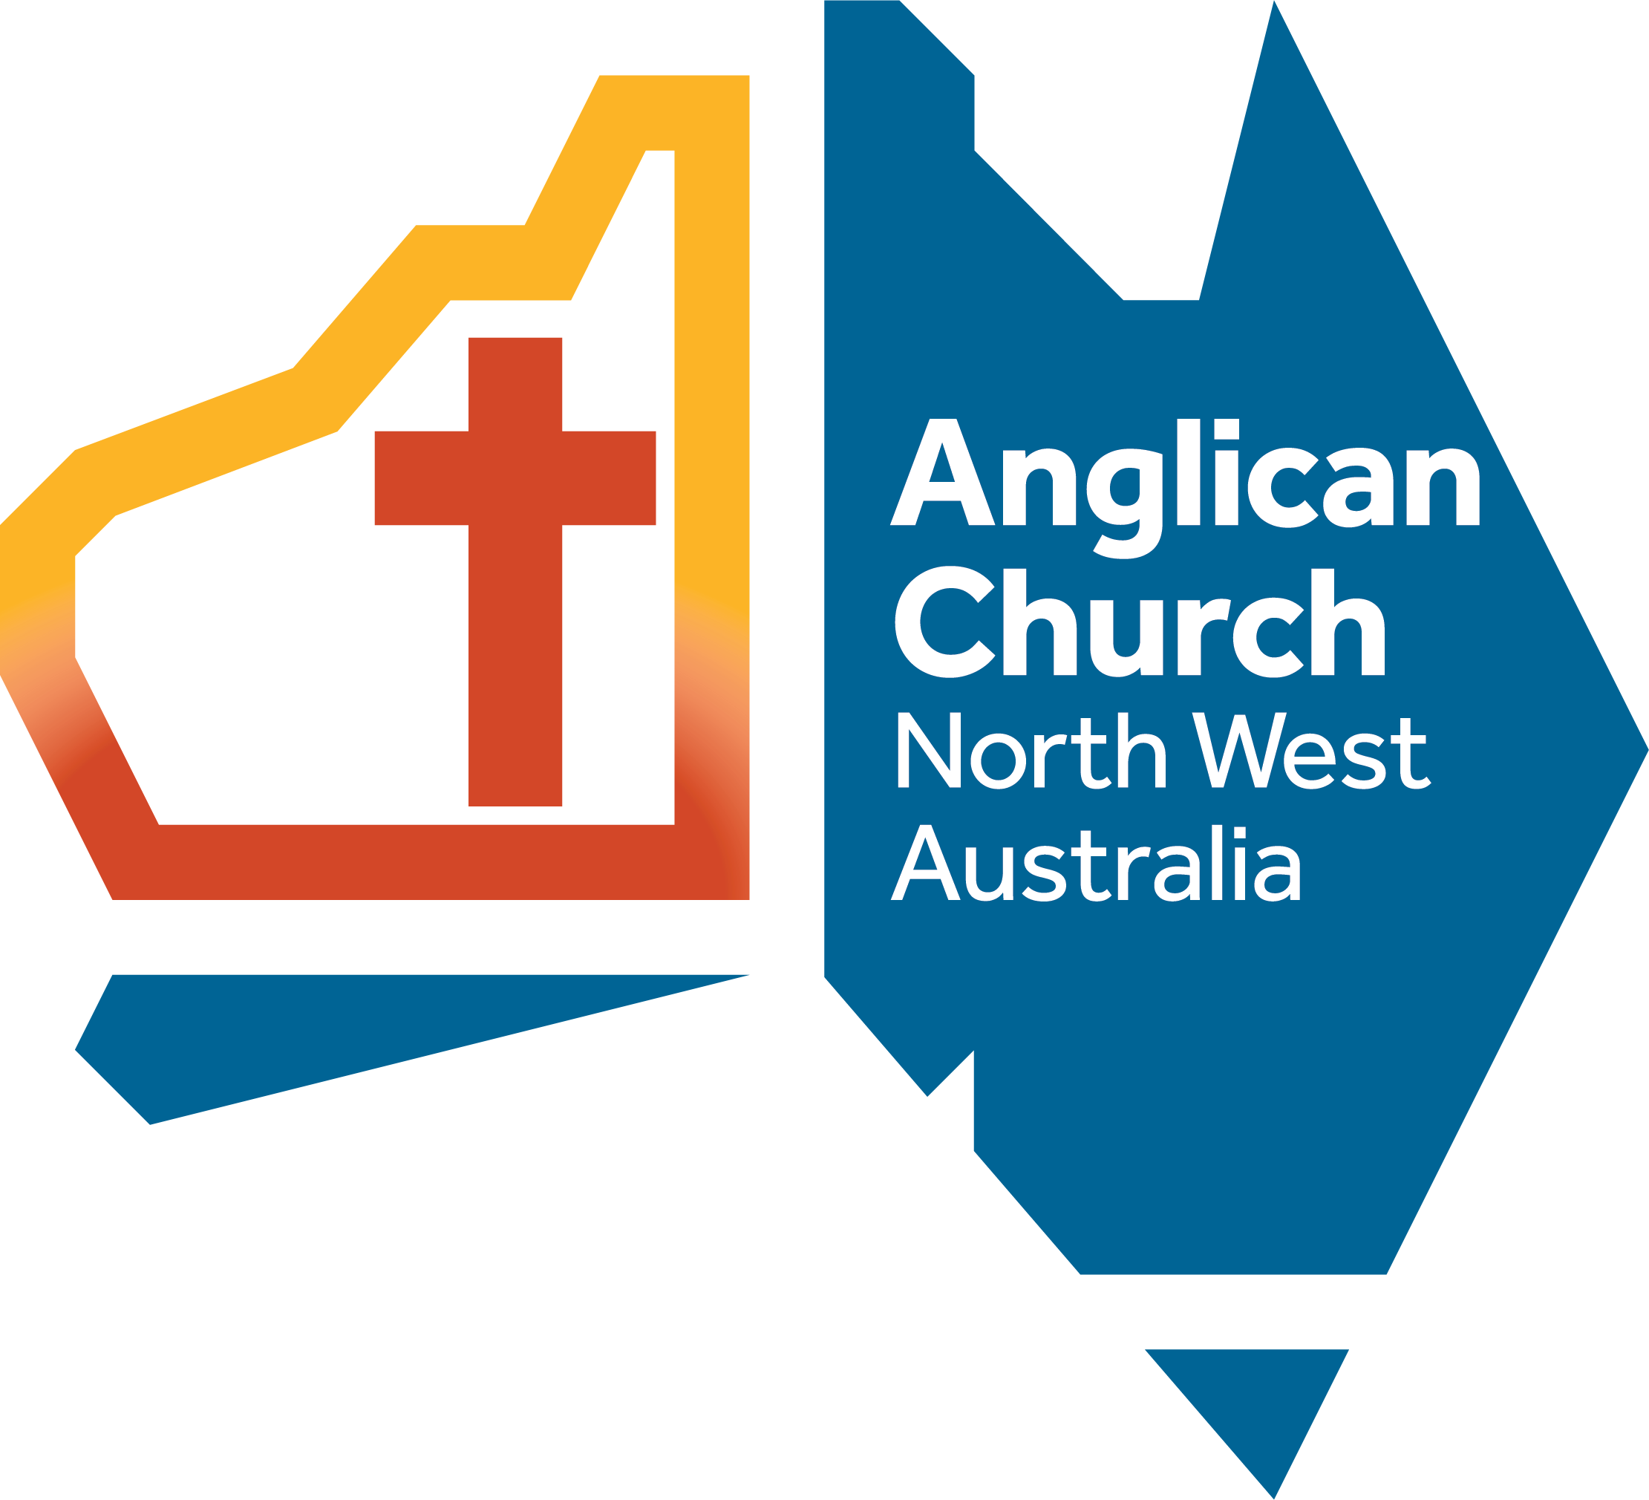
CONTENTS
1 PURPOSE 1
2 SCOPE 1
3 POLICY STATEMENT 2
4 RESPONSIBILITIES 3
Compliance, monitoring and review 3
Reporting 3
Records management 3
5 DEFINITIONS 3
6 RELATED LEGISLATION AND DOCUMENTS 4
7 FEEDBACK 4
8 APPROVAL AND REVIEW DETAILS 4

PURPOSE
This policy is to help ensure that, where a Person of Concern is currently participating or wishes to participate in the life of a Ministry Centre of the Diocese, people in the ministry centre are not placed at increased risk of being harmed.

SCOPE
This policy includes people who include one or more of the following:
  - a person who has pleaded guilty to, has been convicted of, or has admitted to having committed, a criminal offence which includes any element of Sexual Misconduct; or
  - a person who is currently charged with a criminal offence which includes any element of Sexual Misconduct; or
  - a person who has been disciplined or had other action taken against them under a disciplinary or professional standards process of the Church because of Sexual Misconduct, or who has been refused ordination, employment or appointment in the Church because of an adverse risk assessment arising from Sexual Misconduct; or
  - a person against whom allegations of Sexual Misconduct are currently being dealt with under a disciplinary or professional standards process of the Church; or
  - a person who has been disciplined by an organisation other than the Anglican Church of Australia for Sexual Misconduct; or
  - a person who, as a result of Sexual Misconduct, has received an adverse risk assessment from a professional with appropriate qualifications and experience in accordance with the requirements of another church or a statutory authority; or
  - a person who has received or is receiving treatment for disordered sexual behaviour.
  - A person who has been deemed to be a risk in relation to physical or emotional harm to members of a ministry centre.

POLICY STATEMENT
  - The Diocese of North West Australia is committed to the physical, emotional and spiritual wellbeing of all people, including any survivors of sexual abuse (whether known or unknown), who participate in the life of a ministry centre.
  - The Policy is our attempt to offer life-long safety arrangements (called Standards for Participation and Worship) to those identified to be Persons of Concern, who are seeking to participate in the life of a ministry centre.
  - The Diocese acknowledges that when a Person of Concern participates in the life of the ministry centre, this raises important considerations for ensuring a safe environment, requiring careful attention to pastoral care, support, and appropriate safeguards for the well-being of all individuals and to be protected from risk of harm.
  - A Person of Concern may be invited to participate in the life of a ministry centre provided that both the Person of Concern and the Ministry centre Churchwardens are willing to proceed with the Process of Assessment, and the Person of Concern is willing to meet its requirements, and then only if:
- the Ministry Centre is deemed by the Director of Professional Standards (DPS) and Bishop in consultation with the ministry centre to have the capacity to manage the identified issues and risks; and
- the identified risks as part of the assessment can be managed by the Diocese and ministry centre
  - The Bishop will issue such an invitation only after an assessment of the Person of Concern (if necessary) and a Situational Assessment of the ministry centre indicate that participation is appropriate and there are Standards in place.
  - During the process of Assessment, if the Person of Concern accepts the invitation outlined in 3.5, the Bishop in consultation with the ministry centre shall establish Interim Safety Measures, after an initial risk assessment conducted by the DPS.
  - The DPS shall complete the Assessments (above) and consult the Professional Standards Committee (PSC) in relation to the associated risks.
  - The DPS will inform the Bishop and PSC of the outcome of the Assessments and recommend either the implementation a permanent (life-long) set of Standards or termination any interim Standards that may be in place. In the case of the latter, alternate ministry will be offered.
  - If any ONE or more of the following conditions applies, the Minister in Charge and Churchwardens, as directed by the Bishop must take whatever steps are necessary to minimise the risk of harm to people in their ministry centre:
  - A Person of Concern OR the ministry centre does not wish to proceed with the Process of Assessment; or
  - The Process of Assessment indicates that it is inappropriate for the Person of Concern to participate in the life of the ministry centre; or
  - The Person of Concern refuses to abide by the Standards; or
  - The Person of Concern breaches the Standards. The steps to be taken may include directing the Person of Concern not to participate in the life of the ministry centre. If such a direction is made, the Minister in Charge will discuss with the Bishop what form of Alternative Ministry will be offered to the Person of Concern.
  - The DPS and the PSC or its delegate will be made available to assist Minister in Charge and/or governing group in the implementation of an Interim Standards

  - If a Person of Concern is currently participating or seeks to participate in the life of a ministry centre, the Bishop, DPS, Minister in Charge with the consultation of Churchwardens will agree on the level of disclosure appropriate to protect both people in the ministry centre and the Person of Concern, given all the circumstances.
This will arise at the following stages in the process under this policy:
  - when the Interim Standardsallows the Person of Concern to participate in the life of the ministry centre (Safe Ministry with Persons of Concern Procedure - Stage 3 or 7); or
  - when the Bishop decides that the Person of Concern may participate in the life of the ministry centre (Safe Ministry with Persons of Concern Procedure - Stage 5).
Information should only be disclosed to the extent necessary for the proper implementation of this policy. The Bishop, DPS, Minister in Charge and Churchwardens should take into account the following:
    - the degree of risk of harm to people in the ministry centre;
    - the people who are at risk of harm;
    - the importance of allowing people to make an informed decision of the extent of their own participation or that of their children in the life of the ministry centre. (This factor will have greater weight when there is a specific risk to particular people, such as when the Person of Concern has been found guilty of or has been accused of sexually abusing children of a particular gender and age); andthe extent to which the identity of, and information about, the Person of Concern is known publicly (such as through media reports). Every disclosure of information should be made in a non-sensational manner and with careful consideration of the words used.

RESPONSIBILITIES

Compliance, monitoring and review

Reporting

  - Information regarding Persons of Concern must be reported to the Director of Professional Standards and the Bishop

Records management

  - The secure storage of all documentation related to this Policy is essential. Documentation will be held by the Diocese and retained permanently. The DPS will supply such documentation to the Person of Concern, Minister in Charge and Churchwardens as is necessary for the implementation of the policy.

DEFINITIONS
- Bishop means the Bishop of the Diocese or their delegate.
- Alternative Ministry is the offer of spiritual nurture outside regular Ministry Centre worship services and events and offsite and includes the identification of:
- a ministry centre in whose life the Person of Concern may participate; or
- a member of the clergy who can provide pastoral ministry to the Person of Concern.
- Church means the Anglican Church of Australia.
- Director of Professional Standards or DPS means the Director of Professional Standards or their delegate.
- Interim Standards for Participation and Worship (Interim Standards) specifies what is required to protect people in the ministry centre during the Process of Assessment. The Interim Standards for Worship should, as a minimum, state the conditions for participation of the Person of Concern in the life of the ministry centre OR direct the Person of Concern not to participate in the life of the ministry centre until the Process of Assessment is completed.
- Minister in Charge means the incumbent of the ministry centre by whatever name the person holding the office is called, such as Minister in Charge, priest-in-charge, chaplain.
- Participate in the life of a ministry centre means attending public Worship and/or otherwise participating in activities in a ministry centre.
- Process of Assessment is the process specified in this policy for assessing whether a Person of Concern can participate in the life of a ministry centre.
- Professional Standards Committee (PSC) – A diocesan committee established in accordance with the Diocese of the Northwest Professional Standards Statute
- Standards for Participation and Worship (Standards): a written set of risk and pastoral management measures. It is offered to the Person of Concern by the Diocese (Bishop). The Minister in Charge and Churchwardens on behalf of the ministry centre and the Person of Concern will sign the document to acknowledge their commitment to the implementation of the Standards.
The Standards for Participation and Worship contain:
- the conditions for participation of the Person of Concern in the life of the ministry centre;
- any additional conditions (e.g. an obligation to undertake child protection training);
- the consequences of any breach of the Standards for Participation and Worship by the Person of Concern; and what information should be released to whom.
- Situational Assessment is an assessment of the ministry centre by the DPS.
- Sexual Misconduct is defined in the National Register Canon.

Terms not defined in this document may be found in the Diocesan Glossary.

RELATED LEGISLATION AND DOCUMENTS

Report Conduct scheme
Safe Ministry to Children Statute
Professional Standards Statute
Tribunal Statute
Safe Ministry Policy
Safe Ministry with Persons of Concern Procedure.

FEEDBACK

  - Church members may provide feedback about this document by emailing registrar@anglicandnwa.org.

APPROVAL AND REVIEW DETAILS

Approval and Review | Details
Approval Authority | Diocesan Council
Administrator
Next Review Date
Approval and Amendment History | Details
Original Approval Authority and Date | Diocesan Council 21/02/2024
Amendment Authority and Date | Original Policy adopted by Diocesan Council on 26/08/2023
Notes

